Table of Contents
- Problem Alignment
  - Problem
  - High-level Approach
  - Goals & Key Success Metrics
- Solution Alignment
  - Product
  - Nowted Product Map
  - List of Requirements
  - Feature List, Goals, and Success Metrics
  - Flow
  - Mockup

- Problem
As someone who wants to venture into the world of development, it is essential to have a comprehensive, engaging, and well-written portfolio of applications. Because of this challenge, I need an application that can be created by beginners with minimal experience but meets the criteria mentioned above.
- High-level Approach
From the identified problem, I have decided on two features that can be created by beginners. Here are the details of the features:
  - CRUD (Create, Read, Update, Delete)
CRUD is a feature for adding, reading, updating, and deleting data or content that can be performed by the user. This feature will be the main functionality of the application to be developed.
  - Authorization
With authorization, each user can have their own content and only access their content. This feature can also be created by a beginners but plays an important role.
- Goals & Key Success Metrics
  - CRUD can work without any problem
    - User can add or create new content
    - User can read all contents they have created
    - Users can modify certain content they have created.
    - User can delete certain content they have created
  - Authorization can work without any problem
    - Someone can create a new user account and login with that account
    - User can execute CRUD features to their content until they login
    - User cannot execute CRUD features if they logout or their session expired

- Product
The product form of the application to be created is a note-taking app named Nowted. Why a note-taking app? Because the application solves the problem by having CRUD features and can be integrated with authorization. I took the name Nowted from the codedesign.dev website in the advanced applications section. This application also serves as a solution to the challenge on that website.
- Nowted Product Roadmap
After considering my knowledge and experience, I have a planned timeline for the creation of the product as outlined below:
Figure 2.1 Product Roadmap
- List of Requirements
Requirements | Description
01 | User can create new content
02 | User can read new content they have created
03 | User can modify certain content they have created
04 | User can delete certain content they have created
05 | Someone can create new user
06 | Someone can login to application with user they have created
07 | Only users who are logged in can execute CRUD operations.
08 | Someone cannot execute CRUD features if they don’t have a user account
0 | Someone cannot execute CRUD features if they logout or session expired

- Feature List, Goals, and Success Metrics

- Flow
Below is process shown in user flow that runs at Nowted. For more detail information please access the Figma link here.
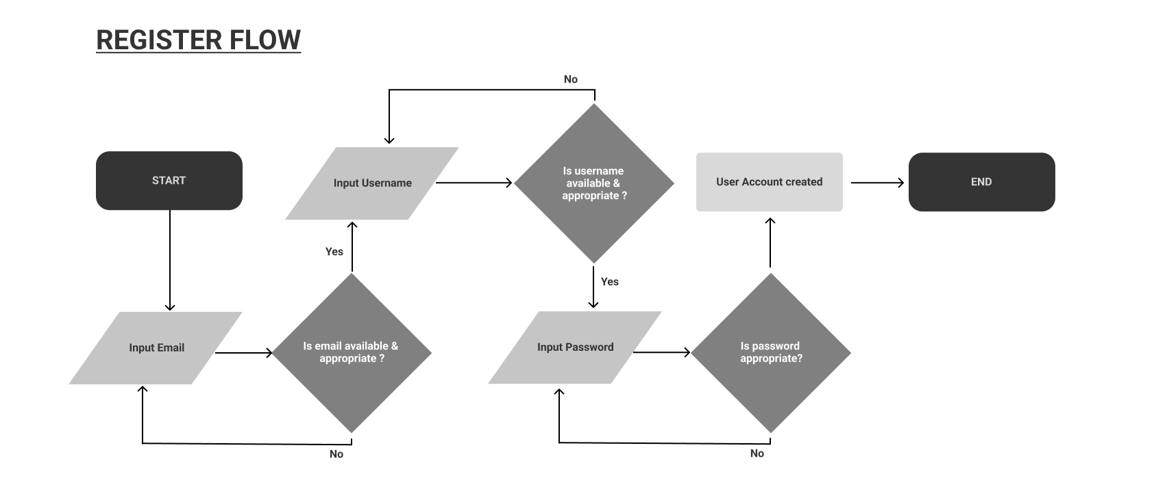
Figure 2.2 Register Process Flow
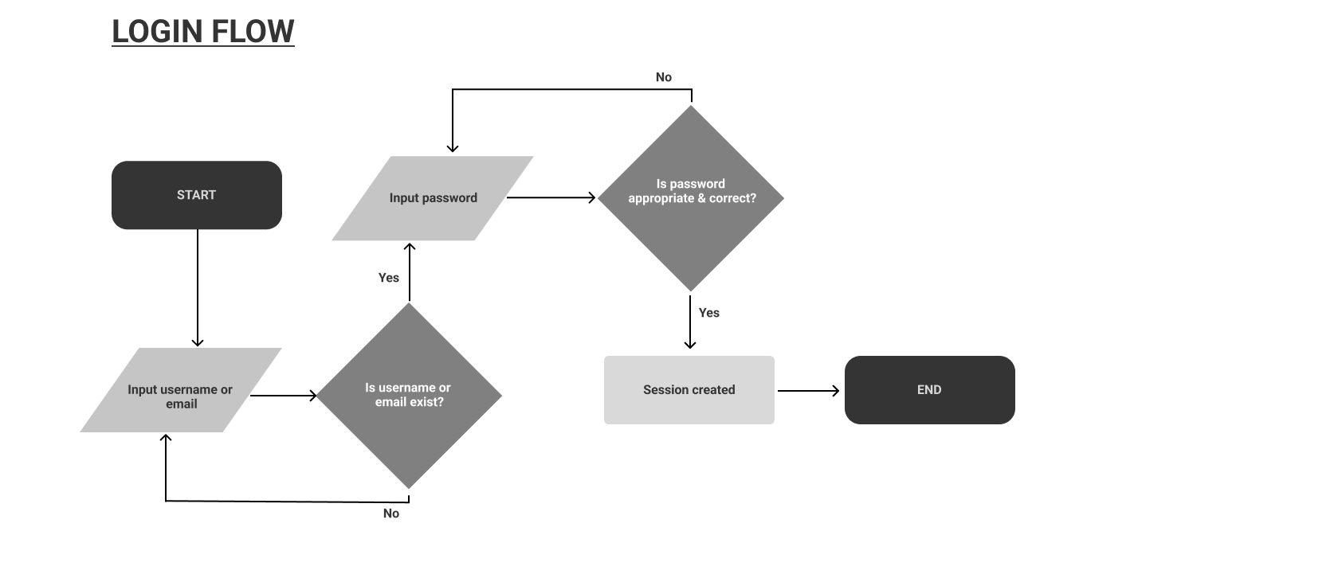
Figure 2.3 Login Process Flow
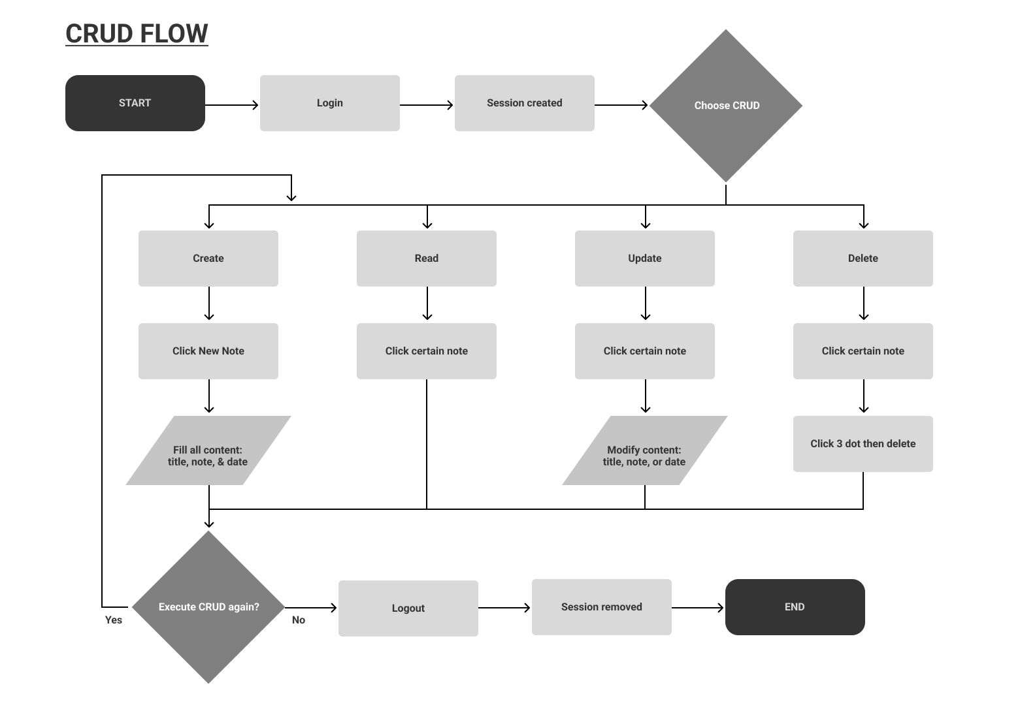
Figure 2.4 CRUD Process Flow
- Mockup
To help understand user stories better, there are mockups to be followed below.
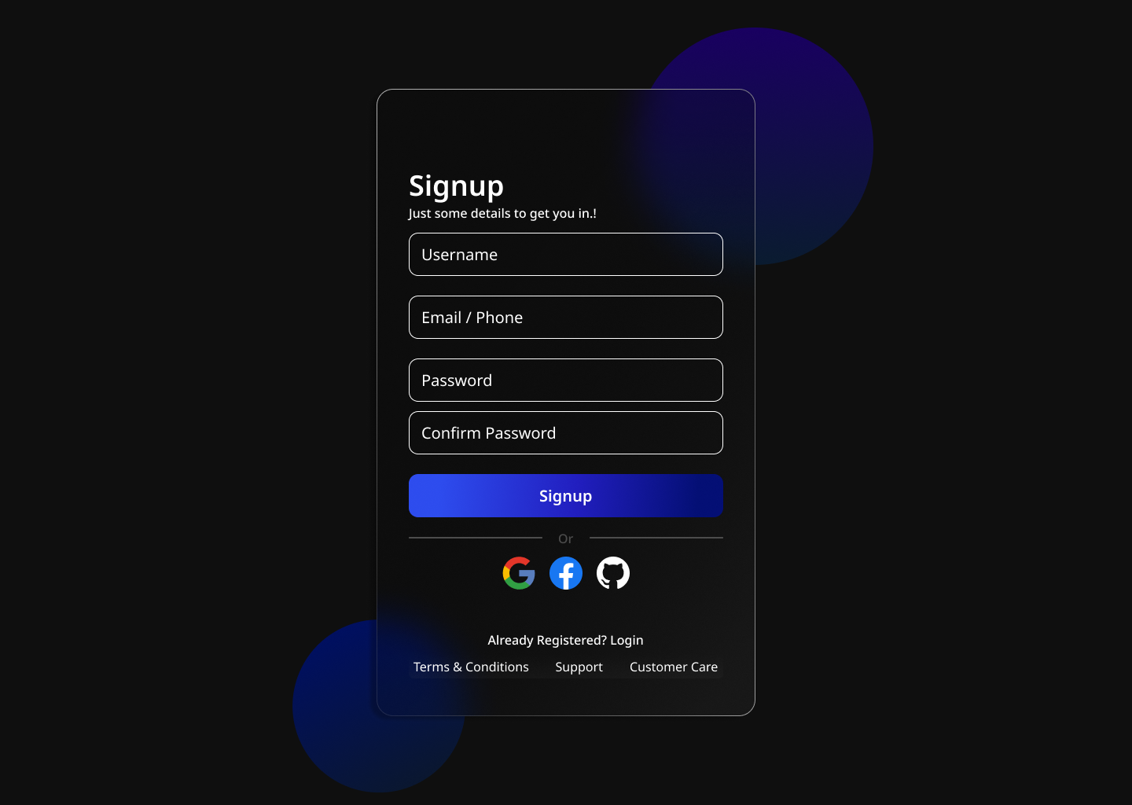
Figure 2.5 Register / Signup Page
This is page for register new account user
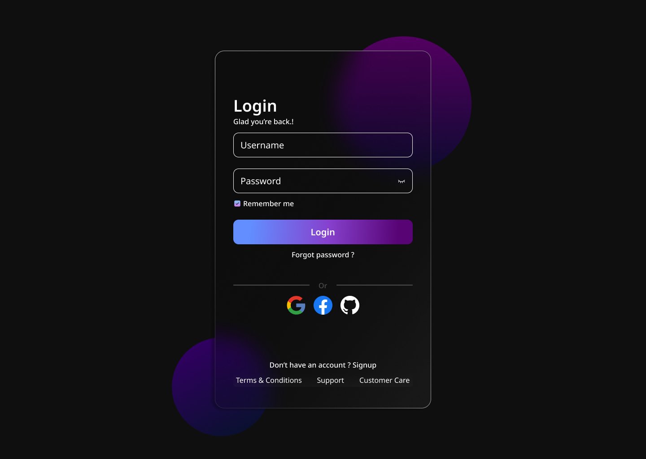
Figure 2.6 Login Page
This is page for login in to application
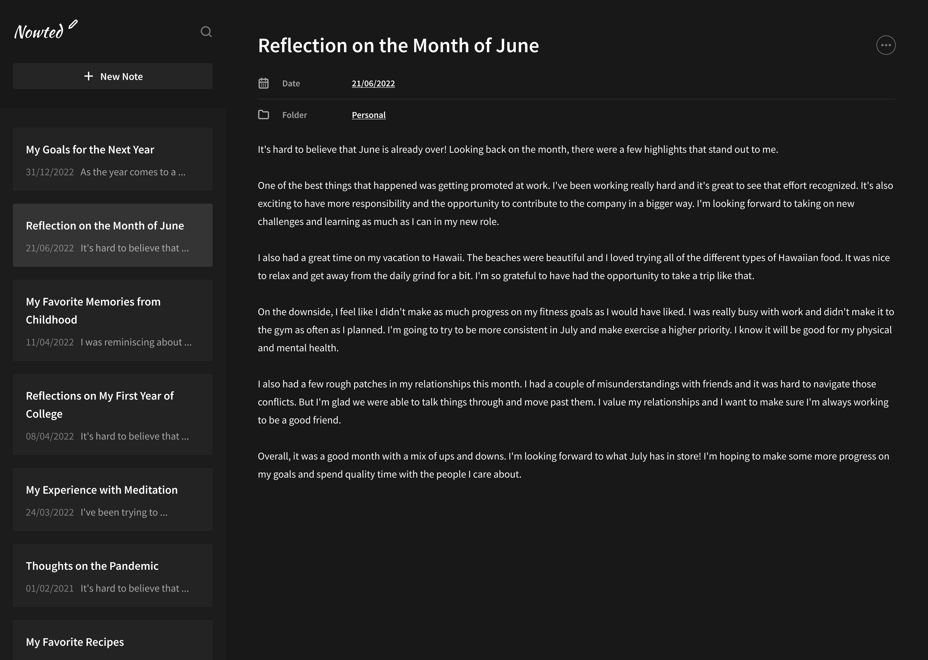
2.7 Main Page
On this page we can execute CRUD features to content

